1. ***Multi-ethnic Survival Prediction: Transfer Learning with Cox Neural Network (kinda useful)***
2. four datasets: KIRC (406EA & 44AA), GBMLGG(582EA & 48 AA), two synthetic ones
3. Cox Neural Network (6 layers):

1. Transfer Learning Strategies:

First one: pre-trained with EA data and fine-tuned with AA

Second one:

1. Evaluation Method: C-index
2. Result:

1. ***Transfer learning with convolutional neural networks for cancer survival prediction using gene-expression data (quite a different way)***
2. Procedure:

*pre-processing: feature reduction

*gene-expression images: use KEGG BRITE functional hierarchies to map from KEGG BRITE database information (existed) to the genes contained in the Pan-Cancer dataset; construct the images based on the genes achieved from the last sub step and recursively divided the images

*transfer learning: non-lung dataset (combination of the rest sub datasets except lung datasets) for pre-training, lung dataset (combination of lung datasets) for fine-tuning

1. Nota Bene:

*all the right-censored samples whose censoring times are below time t must be discarded

*in their experiment, they chose 230 days for the time t to get trade-off between imbalanced datasets and the number of samples

*to alleviate the effects of imbalance, random over-sampling used

*AUC as evaluation metric

1. ***Deep Transfer Learning and Radiomics Feature Prediction of Survival of patients with High-Grade Gliomas (useless)***
2. About survival prediction based on the medical images (including segmentation…)
3. So has nothing to do with our topic
4. ***Deep Feature Transfer Learning in Combination with Traditional Features Predicts Survival Among Patients with Lung Adenocarcinoma (useless)***
5. Same as the third paper, it’s more about image classification
6. ***TLSurv: Integrating Multi-Omics Data by Multi-stage Transfer Learning for Cancer Survival Prediction (useful)***
7. Dataset: LUAD dataset with five data modalities (copy number variation/DNA methylation/miRNA expression/mRNA expression and survival outcomes)
8. Procedure:

1. Network architecture:

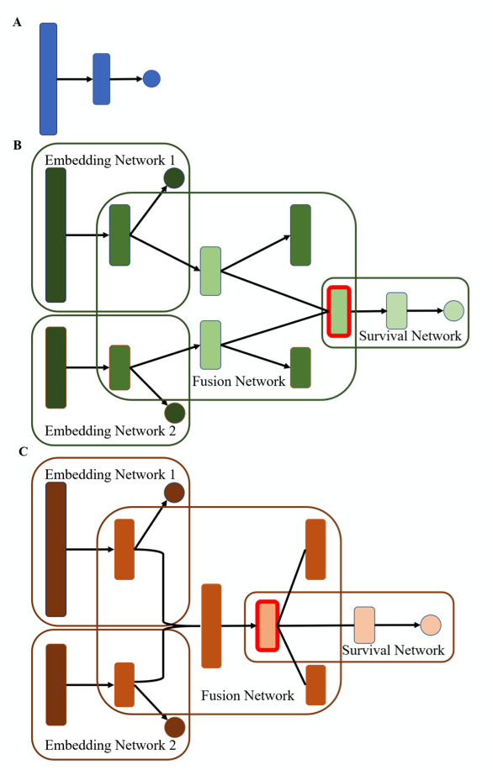

Figure A Cox-nnet as baseline model. In Figure B and C, then first embedding section will reduce dimensionality. Fusion Network will merge the data modalities while the last survival network’s output neuron is a classic log-partial hazard function.

1. Evaluation metric: C-index
2. Summary of novelty:

